E-sig integration - DocuSign Fillable Form
- New syntax introduced, to use this feature, you need to include this in your WPV, otherwise, system will only use the previous version of pdf/e-sig document generation process:
<!--DynamicFormat 1 -->
- The new syntax allows you to create more dynamic content, for all of the following, now you can specify the x and y offset of the placement around the anchor text that’s used to specify where the block is located in the document, unit as pixels:
- SignatureBlock
- InitialsBlock
- DateBlock
- DateSigned
- FieldBlock
<!—Blocktype anchorstring;;xoffset;;yoffset;; -->
<!—Blocktype anchorstring;;xoffset;;yoffset;;width;;height --> (applicable for FieldBlock)
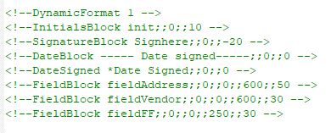
Example:
<!--InitialsBlock init;;0;;10 -->
- place the mandatory initials block in document where the word “init” is found in the html of the WPV, and xoffset=0, yoffset=10
OR
setting this to color:#ffffff makes the content not visible, and the ~Index~ helps to specific which person’s initial is required, in the above examples “init2” specified that the 2nd signee in the list should leave their initials there
<!--SignatureBlock Signhere;;0;;-20 -->
- place the mandatory signature block in document where the word “Signhere” is found in the html of the WPV, and xoffset=0, yoffset=-20
setting this to color:#ffffff makes the content not visible, -20 offset makes the signature block position somewhere above the line drawn in the html here.
- For dynamic format, you have to specify the index in the html content
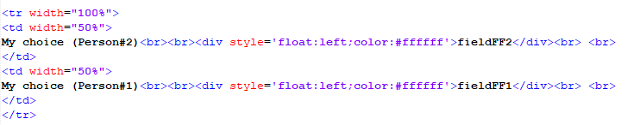
Example: top row is targeting to Person#2 to fill in, so with the anchorstring “fieldFF” which specify the placement for the fillable field, instead of fieldFF, you put fieldFF2 so that DocuSign knows that when person2 opens the document, they have to fill in this field. (see screenshot below)
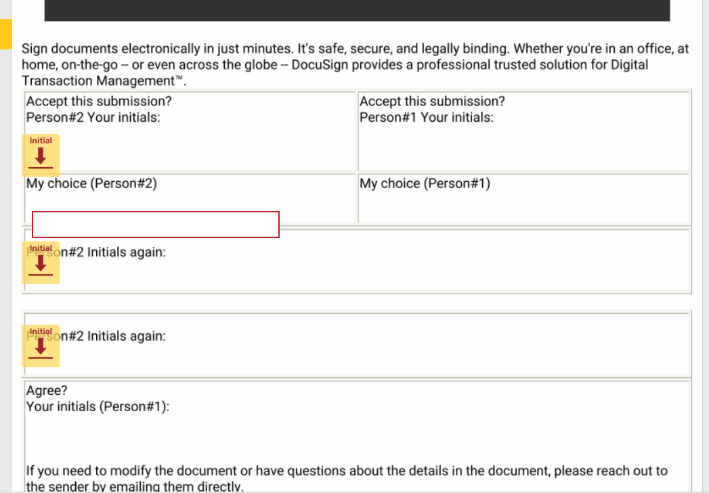
Alternatively, if you use the syntax below, that means for every L1 contacts with the role=12527 ordered by firstname, they will all have to put their initials, signature, and also fille in the fieldVendor and fieldAddress fields in the form.
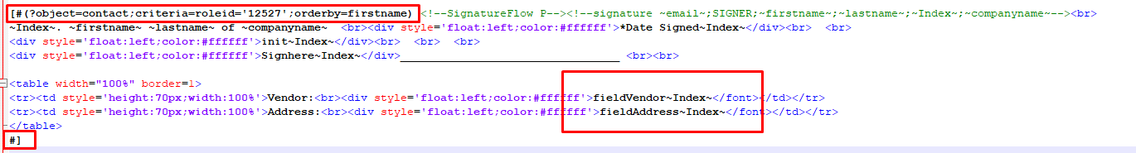
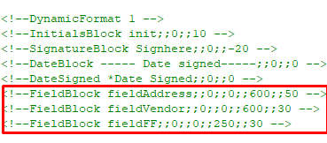
*width = 600, height=50 for Address
*width = 600, height=30 for Vendor
